Please read ‘Food Supplement Guidelines’ for details on necessary regulatory requirements for labelling.

For presentation to the UK market

On labels, clients may use the name Superba Krill™ when describing the ingredient, and in the ingredients list, but it may NOT be used as the product name.

If you would like to use the trademark, please contact hello@nutribl.com for further information about setting up the trademark agreement with the raw material supplier. You may also use the eco harvesting logo. This is free to use and available in two colours, green or black and white.

Logo for use only on signing of trademark agreement after contacting heloo@nutibl.com
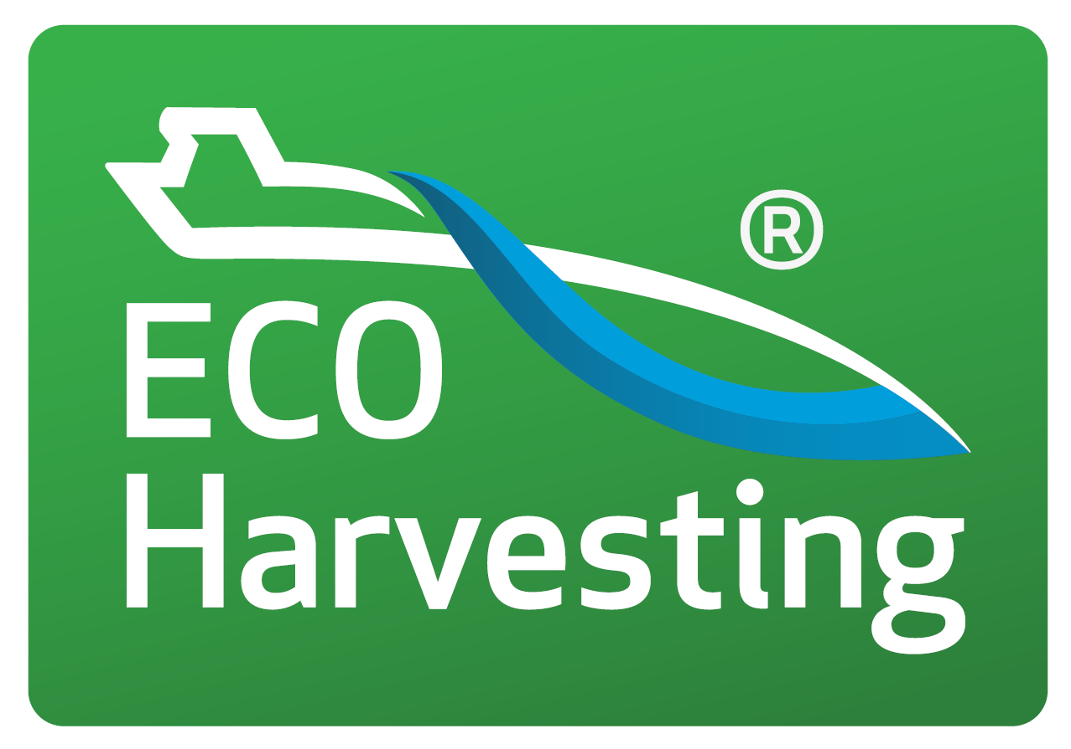

FRONT LABEL

Pure Krill Oil (or own Product Name- take care not to breach legislation with regard to claims )

Food Supplement -Containing Sustainably Fished Superba Krill™ extracted from Antarctic Krill, with Astaxanthin.

Claims (can appear anywhere on pack). You should include at least one approved health claim on the pack as this helps to justify more generic claims such as "healthy".

HIGH IN Omega-3 fatty acids.
EPA and DHA contribute to the normal function of the heart. ⁽¹⁾
DHA contributes to maintenance of normal brain function & normal vision. ⁽²⁾

You can search for other Nutrition & Health Claims approved for use in the UK here https://www.gov.uk/government/publications/great-britain-nutrition-and-health-claims-nhc-register?utm_medium=email&utm_campaign=govuk-notifications&utm_source=f8d61ec9-adf6-459d-bdfe-7aa9674beaec&utm_content=weekly.

60 Softgel Capsules
BACK LABEL

Directions:
Adults, take 2 softgel capsules per day, with water. Do not exceed recommended daily dose.
⁽¹⁾ The beneficial effect is obtained with a daily intake of 250 mg of EPA and DHA.
⁽²⁾ The beneficial effect is obtained with a daily intake of 250 mg of DHA.

Product Information:
Two softgels typically provide:

Krill Oil  providing:  Total Phospholipids  Phosphatidyl Choline  Choline  Total Omega 3  EPA (Eicosapentaenoic Acid)  DHA (Docosahexaenoic Acid)  Astaxanthin | 1000mg  400mg  300mg  50mg  220mg  120mg  56mg  100µg

Ingredients:
Krill Oil (as Superba Krill™)(Crustaceans), Capsule Shell: (Fish Gelatin, Glycerol, Sorbitol).

Allergy Advice: Potential allergens contained in this product are shown in the ingredients list in bold. Although rigorous precautions are taken to prevent any cross-contamination, this product is manufactured in a facility that handles allergy-based materials.

Cautions:
Always consult your health practitioner before taking nutritional supplements, especially if you are taking medication or are under medical supervision. You should not take supplements as a substitute for a varied balanced diet or healthy lifestyle. Store in a cool (between 5 – 25 °C) dry place, out of reach of children. Not suitable for vegetarians or vegans.

Best Before:
For best before end and batch number see base.

Manufactured to the GMP code of practice for:
Name or business name and address of the food business operator

PLEASE NOTE: If you are selling in/exporting to the EU you will need to include the address details of the Food Business Operator, or Importer, based in the EU. You can have a UK address and an EU address if selling in both territories.

Please give files following file names:
Front Label: PL-HSKRIL$front
Back Label: PL-HSKRIL$back

Label Size
709px x 897px at 600DPI (that's 60mm x 76mm)

NON-EXCLUSIVE TRADEMARK LICENSE AGREEMENT

Sublicensor Aker BioMarine Antarctic AS, Oksenøyveien 10, 1327 Lysaker, Norway

Sublicensee Name:
Address:

Territory [home market + all countries the products will be sold]

Trademark Eco-Harvesting™

License Grant
Sublicensee is hereby granted a non-exclusive right to use the Trademarks for the sole purpose of marketing, offering for sale and selling dietary supplement products containing at least 500mg of Sublicensor’s SuperbaTM Krill Oil per capsule (hereinafter the ‘Products’) in the following sales channels: [list all relevant sales channels]
For the sake of clarity, Sublicensee agrees that its rights under this Agreement are limited to Territory and that Sublicensee has no rights, as described in this Agreement, outside of Territory. Furthermore, no royalty payments are due under this license agreement and Sublicensee is responsible for its own freedom to use the Trademarks in the Territory.

Terms of Use
With respect to this Agreement, use of the Trademarks is restricted to the promotion of Products that carry a main product trademark owned or licensed to Sublicensee.
Sublicensee agrees that it shall not feature, display, nor relate in any manner, either directly or indirectly, the Trademarks to any of its products or ingredients that do not contain at least 500mg of Sublicensor’s SuperbaTM Krill Oil per capsule and therefore are not part of this Agreement.
Sublicensee undertakes to always include the superscriptTM after the Trademarks and (when customary) accompany its use of the Trademarks by the following statement: ‘Eco-Harvesting™ is a trademark of Aker BioMarine’.
Any use of the Trademarks on Product labels and boxes shall be approved in advance by Sublicensor to secure the application is according to the granted license. Without limitation to the foregoing, Sublicensee shall ensure that all labeling, advertising and informational materials relating to sales of Products using the Trademarks shall conform to all applicable laws and regulations, and shall obtain all appropriate governmental approvals pertaining to the sale, distribution and advertising of such Products.
Sublicensee agrees never to apply for registration of the Trademarks, or confusingly similar trademarks, in any territory, or to register any domain name containing the Trademarks or words confusingly similar to the Trademarks. In case of breach of these obligations, Sublicensee undertakes to transfer ownership to such applications or registrations to Sublicensor free of charge.
Sublicensee warrants that all of its contract manufacturers and vendors involved in the manufacturing or sale of Products are aware of and made subject to the terms of this Agreement. Otherwise, this license grant is not transferable or eligible for sublicensing without Sublicensor’s written consent. Sublicensee has no independent right to enforce the Trademarks in the Territory or elsewhere.
This license grant depends on the existence and terms of Sublicensor’s license and may be withdrawn or restricted by Sublicensor with immediate effect in case of breach or misuse by Sublicensee, or threats from third parties of trademark infringement litigation. Sublicensor may otherwise withdraw or restrict the granted license providing three months’ prior written notice to Sublicensee.

SUBLICENSOR SUBLICENSEE

------------------------------------------ -------------------------------------
Position: Position:
Date: Date:

Appendix: Aker BioMarine Eco-Harvesting™ device/logo

